**How to search vendor in SAP**

**如何在SAP系统中查找供应商**

|  |  |  |  |
| --- | --- | --- | --- |
| **Transaction Name**  **操作名称** | **Transaction Code**  **操作代码** | **Usage**  **用途** | **Search Method**  **查找方法** |
| Vendor Master Data Display & Reporting  供应商主数据展示及报告 | XK03 | Check if vendor already exists and see vendor related information  查看供应商是否已存在及供应商相关信息 | 1．Search by Vendor Name  通过供应商名称查找  2．Check by Vendor’s Tax Number  通过供应商税号查找 |

This transaction (XK03) is under SAP role of “DM-3153 Vendor Master Data Display & Reporting” in CA7 Box, if you don’t have access, please contact your site Procurement or Super User, or email “MDC,GreaterChina,Beijing,GLOBE IS/IT” for help.

此操作（XK03）属于SAP CA7中的“DM-3153 Vendor Master Data Display & Reporting”角色，如果您没有该权限，请联系当地采购人员或Super User，或者发邮件至“MDC,GreaterChina,Beijing,GLOBE IS/IT” 询问。

**1. Search by Vendor Name（通过供应商名称查找）**

(1) Enter the interface of “Display Vendor (XK03)”, click on the icon  in “Vendor” field;

进入Display Vendor (XK03) 的界面，点击“Vendor”右侧文本框旁边的按钮；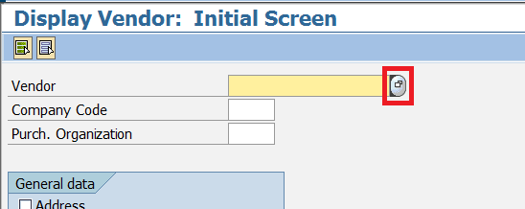

(2) Click on the icon  to find and select “Vendors by Address Attributes”;

点击右上角按钮，查找并选择 “Vendors by Address Attributes”；

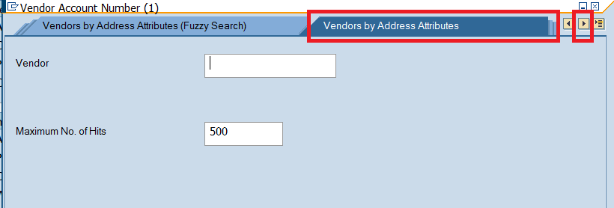

(3) Type key words from vendor name with “*” at the beginning and end, click on the green tick and see if your searched vendor is in the list by checking address information.

输入供应商名称中的关键词并使用“*”隔开，选择左下角绿色对勾，在搜索结果中，通过核对地址信息确认是否有您的搜索目标。

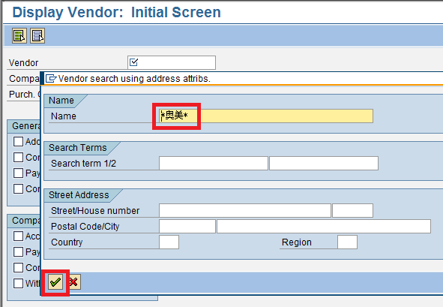

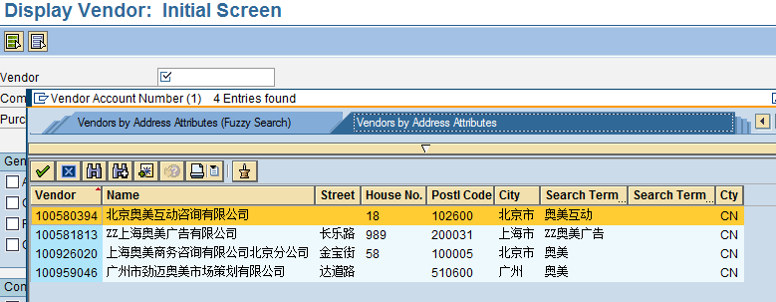

**2. Search by Vendor’s Tax Number（通过供应商税号查找）**

(1) Enter the interface of “Display Vendor (XK03)”, click on the icon  in “Vendor” field;

进入Display Vendor (XK03) 的界面，点击“Vendor”右侧文本框旁边的按钮；

(2) Click on the icon  to find and select “Vendors by Tax Information”;

点击右上角按钮，查找并选择 “Vendors by Tax Information”；

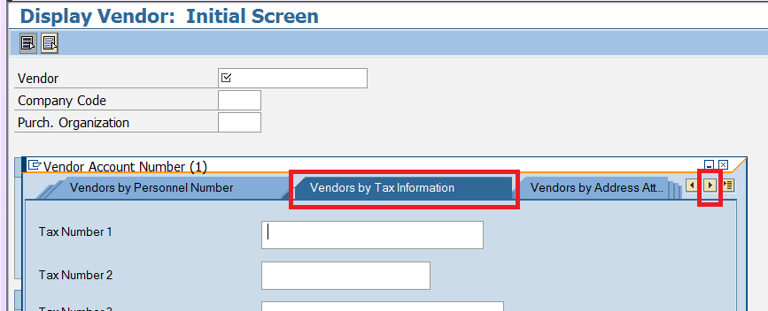

(3) If vendor’s Tax Number is 15-digit, type in “Tax Number 1”; if Tax Number is more than 15 digits, type the first 15 digits in “Tax Number 1” and the remaining ones in “Tax Number 2”, and see if your searched vendor is there.

对于15位税号的供应商，在Tax Number 1输入15位税号；对于超过15位税号的供应商,，在Tax Number 1输入税号的前15位，在Tax Number 2输入剩下的税号，以查看您的搜索目标是否存在。

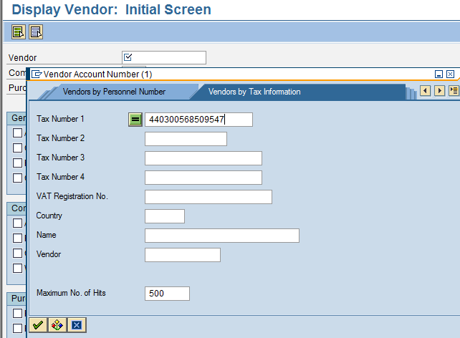

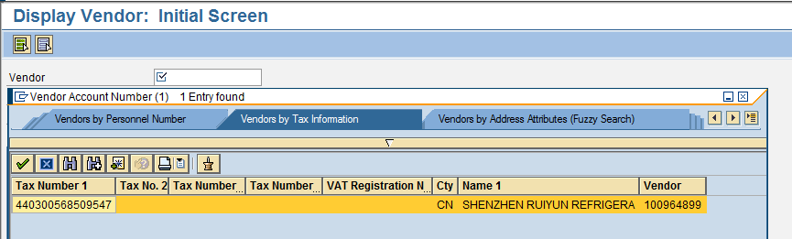

Remark: searching result by Tax Number is unique, but vendor’s Tax Number may be changed after obtaining new Business License with 3 codes; so the most secure way is to search by both name and Tax Number.

注：利用税号搜索出的结果是唯一的，但无法排除由于三证合一导致税号更改的情况，因此最保险的方法是结合两种方法进行搜索。